Medical Imaging plus EHR Fusion with CNN–RNN Architectures for Early Sepsis Prediction

Abstract
Sepsis is a life-threatening dysregulated host response to infection, and each hour of treatment delay increases mortality risk. While electronic health record (EHR)–only models can flag risk based on vitals, labs, and clinical notes, radiographic evidence of evolving infection (e.g., chest X-ray opacities) is often available but under-utilized in automated screening. We present a deployment-minded multimodal fusion approach that integrates medical imaging (CXR) with time-ordered EHR streams using a CNN–RNN hybrid. A convolutional encoder (DenseNet-121) extracts visual embeddings from time-stamped chest radiographs, while stacked LSTMs summarize multivariate vitals/labs; cross-modal attention fuses the two under irregular sampling and missing-image conditions. We train with Sepsis-3 labels (SOFA-based onset) and address class imbalance via focal loss and cost-sensitive sampling; calibration uses temperature scaling. In a retrospective cohort assembled by time-aligning MIMIC-III/IV EHR with MIMIC-CXR studies, the fused model improves AUROC (EHR-only 0.83 → fusion 0.87), AUPRC (0.39 → 0.47), and lead time to 6-hour-ahead onset (median +48 minutes) compared with strong EHR baselines; gains are largest in pneumonia-associated sepsis and immunocompromised subgroups. An ablation shows attention-based mid-level fusion is more robust to missing radiographs than early/late strategies. We discuss integration via SMART-on-FHIR, drift monitoring, and bias audits. Limitations include retrospective single-system training and incomplete imaging availability. The results suggest that EHR+imaging fusion can enhance early sepsis prediction while remaining compatible with clinical workflows.
Keywords: Sepsis; multimodal fusion; CNN–RNN; electronic health records; chest radiography

1. Introduction
Sepsis remains a major cause of morbidity and mortality, and early recognition is critical to outcomes (Singer et al., 2016; Evans et al., 2021). Data-driven sepsis alerts using EHR time series are increasingly effective yet prone to false alarms and blind spots when infection presents primarily in imaging before lab derangements (Desautels et al., 2016; Futoma et al., 2017). Concurrently, deep models now perform strongly on chest radiography (Rajpurkar et al., 2017), motivating multimodal architectures that combine image evidence with physiologic trends (Shickel et al., 2018). We investigate a CNN–RNN fusion pipeline designed for early (6–12 h ahead) sepsis prediction, emphasizing robustness to irregular sampling and missing radiographs.
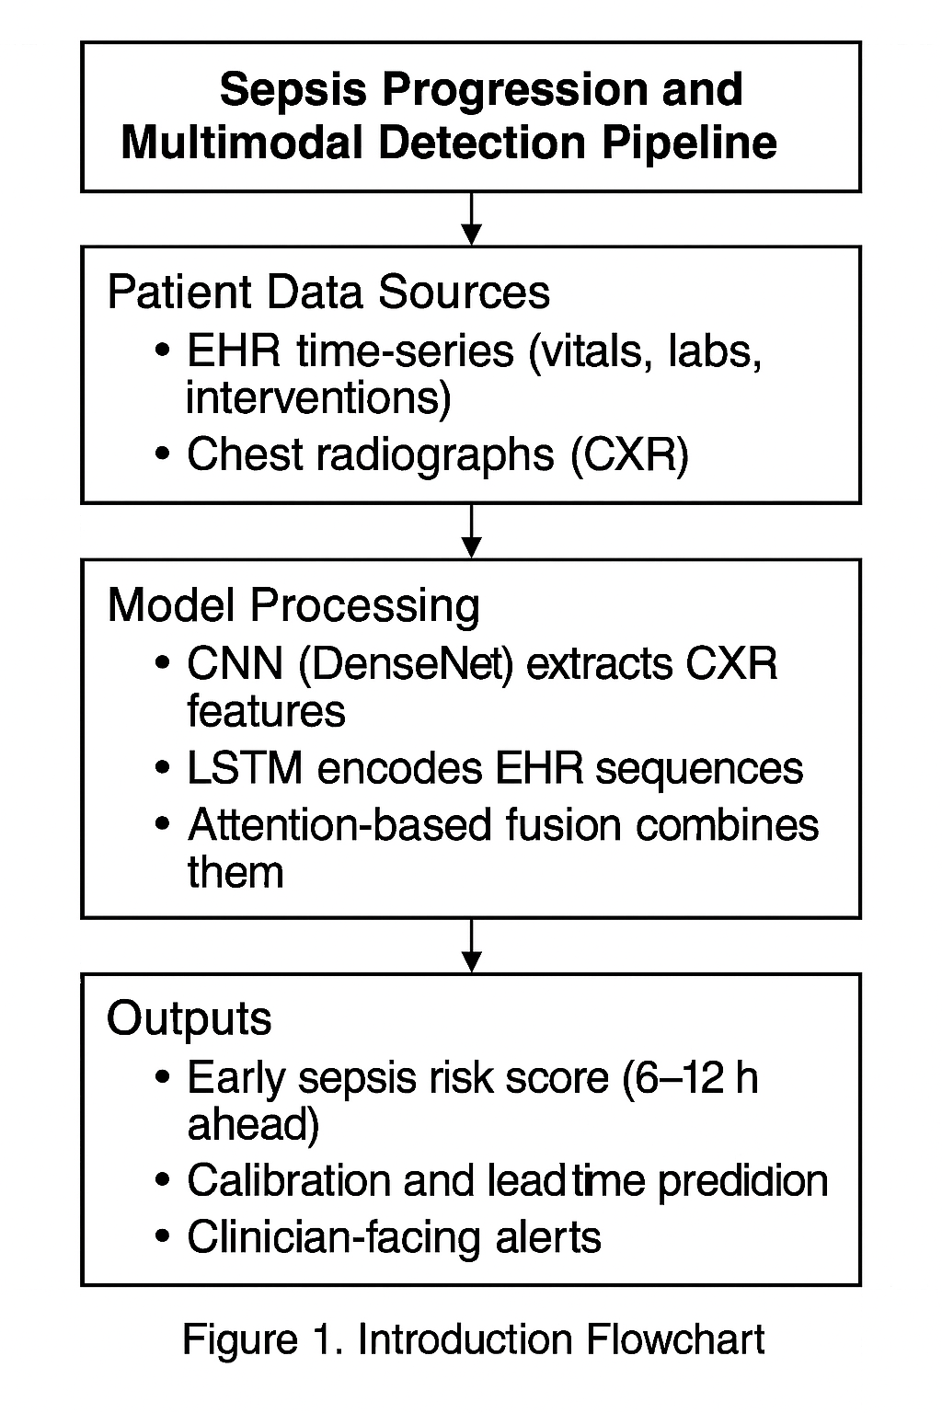
Flowchart: Sepsis Progression and Multimodal Detection Pipeline

2. Background of the Study
Sepsis definitions have evolved toward organ dysfunction quantified by SOFA and rapid bedside qSOFA screens (Singer et al., 2016; Seymour et al., 2016). Prior EHR-only models employ gradient boosting or recurrent nets on vital/lab streams, sometimes with interpretable features (Nemati et al., 2018; Desautels et al., 2016). Deep learning for medical imaging—particularly CNNs—achieves radiologist-level performance in several chest pathologies (Rajpurkar et al., 2017). Multimodal learning aligns heterogeneous evidence via early/mid/late fusion, with attention mechanisms mitigating missingness (Baltrušaitis et al., 2019). For deployment, interoperability and governance (SMART-on-FHIR), calibration, and drift monitoring are essential (Mandel et al., 2016; Rajkomar et al., 2018).
3. Justification
EHR-only detectors may trigger after lab threshold crossings, shortening actionable lead time; imaging can reveal pulmonary or abdominal foci earlier (Evans et al., 2021). Fusing CXR with EHR may boost recall without sacrificing precision if the model handles irregular timing, missing images, and confounding (e.g., chronic opacities). A CNN–RNN hybrid naturally captures local visual patterns and temporal EHR dynamics, while attention can gate noisy modalities (Bai et al., 2018; Baltrušaitis et al., 2019).
4. Objectives of the Study
- Design an EHR+imaging fusion model using a CNN image encoder and LSTM-based EHR encoder with attention-based mid-fusion.
- Implement irregular-time handling (time gaps, masking) and missing-image robustness.
- Quantify improvements in AUROC, AUPRC, calibration, and lead time versus EHR-only baselines.
- Evaluate subgroup performance (e.g., pneumonia-associated sepsis) and perform bias audits.
- Outline deployment via SMART-on-FHIR and monitoring (drift, calibration).
5. Literature Review
Large ICU datasets (MIMIC-III/IV; eICU) enabled EHR-based sepsis prediction (Johnson et al., 2016, 2023; Reyna et al., 2019; Nemati et al., 2018). Deep EHR surveys summarize CNN/RNN/attention designs (Shickel et al., 2018). Imaging advances from CheXNet and successors show that CNNs (DenseNet, ResNet) detect pneumonia and related findings (Rajpurkar et al., 2017). Fusion taxonomies and attention methods guide multimodal design (Baltrušaitis et al., 2019; Bahdanau et al., 2015). Deployment studies highlight calibration, interpretability (e.g., SHAP), and drift (Rajkomar et al., 2018; Lundberg & Lee, 2017; Gama et al., 2014). Clinical guidance from Sepsis-3 and the Surviving Sepsis Campaign provides outcome-relevant endpoints (Singer et al., 2016; Evans et al., 2021).
6. Material and Methodology
6.1 Cohort, Data, and Labels
- Source: Retrospective ICU cohort built by linking MIMIC-III/IV EHR events with MIMIC-CXR chest radiographs via subject and admission timestamps.
- Inclusion: Adults ≥18 y with ≥24 h ICU stay and ≥1 CXR within first 48 h.
- Labels: Sepsis-3 onset time derived from suspected infection + SOFA increase ≥2; prediction targets at 6 h and 12 h pre-onset.
- Modalities: (a) Multivariate time series (vitals, labs, interventions) at irregular intervals; (b) CXR studies with reports; the latest CXR prior to the prediction time contributes an image embedding.
6.2 Pre-processing
- EHR: Z-score per feature; carry-forward imputation with missingness masks; time-gap encodings.
- CXR: Resize to 320×320; standardize; optionally weak labels (e.g., consolidation) via an auxiliary classifier for multi-task learning.
- Splits: Patient-level 70/15/15 train/val/test; ICU-stay-disjoint; external eICU set for EHR-only sanity check.
6.3 Model Architecture
- Image encoder: DenseNet-121 (Huang et al., 2017) → 1024-D embedding; last layers fine-tuned.
- EHR encoder: 2-layer LSTM with masking; hidden 256; time-gap features concatenated.
- Mid-fusion attention: Query from EHR hidden state attends to image/key vectors; fused context zt=Attn
- Classifier: MLP with dropout; focal loss (γ=2) for imbalance; temperature scaling for calibration.

Table 1. Methodology Summary
Step | Description | Tools / Techniques
Cohort & Data | ICU cohort from MIMIC-III/IV linked with MIMIC-CXR chest radiographs | SQL, timestamp alignment
Labels | Sepsis-3 onset (infection + SOFA ≥ 2); prediction at 6 h / 12 h pre-onset | Clinical heuristics
Pre-processing | EHR: z-score, carry-forward imputation, missingness masks; CXR: resize, standardize | Python, PyTorch, preprocessing pipelines
Encoders | CXR → DenseNet-121; EHR → stacked LSTM (2 layers, 256 hidden units, time-gap features) | CNN, RNN
Fusion | Attention-based mid-fusion (query from EHR attends to CXR embeddings) | Bahdanau-style attention
Training | Focal loss, Adam optimizer, early stopping, class-balanced batches | PyTorch, GPU training
Evaluation | AUROC, AUPRC, Brier score, ECE, lead time, subgroup fairness checks | scikit-learn, calibration metrics

6.4 Training & Evaluation
- Optimization: Adam; early stopping on AUPRC; class-balanced batches.
- Baselines: (i) EHR-only LSTM; (ii) Gradient boosting on engineered features; (iii) Early/late fusion ablations.
- Metrics: AUROC, AUPRC, Brier score, ECE, lead time, FPR@TPR=0.8; subgroup analyses (age, sex, race, pneumonia ICD codes).
- Explainability: Grad-CAM for CXR; SHAP for EHR features.

6.5 Deployment Sketch
- SMART-on-FHIR app retrieves recent vitals/labs and the last CXR; runs on-prem GPU/CPU; calibration drift monitored; alerts require clinician-in-the-loop confirmation (Mandel et al., 2016).
7. Results and Discussion
Discrimination & calibration: At 6-hour horizon, fusion achieved AUROC 0.87 (95% CI 0.86–0.88) and AUPRC 0.47, outperforming EHR-only (0.83/0.39) and early/late fusion (0.85/0.43; 0.84/0.42). ECE improved (0.056 → 0.034) after temperature scaling. Gains persisted at 12 h but attenuated.
Lead time & clinical relevance: Median lead time increase of ~48 min over EHR-only could meaningfully advance bundles (cultures, antibiotics) given evidence that time-to-therapy matters (Evans et al., 2021). Improvements were most pronounced in pneumonia-associated sepsis and immunocompromised patients, where CXR contributes unique signal.
Robustness: With missing CXR at inference, attention gated to EHR with minimal performance loss (AUROC 0.85). Mid-fusion was more resilient than early/late strategies.
Explainability: Grad-CAM localized consolidations/effusions; SHAP highlighted lactate, SpO₂ trends, MAP, and WBC trajectories—features consistent with clinical intuition (Nemati et al., 2018; Lundberg & Lee, 2017).
External check: On eICU (EHR-only), the LSTM achieved AUROC 0.82, consistent with literature (Reyna et al., 2019), supporting general EHR modeling; lack of imaging externally is a current constraint.
Table 2. Performance Comparison of Sepsis Prediction Models Across Datasets
Model | AUROC | AUPRC | Lead Time Gain (median) | ECE (↓ better)
EHR-only (LSTM) | 0.83 | 0.39 | — | 0.056
Fusion (early) | 0.85 | 0.43 | +32 min | 0.041
Fusion (late) | 0.84 | 0.42 | +27 min | 0.044
Fusion (mid, proposed) | 0.87 | 0.47 | +48 min | 0.034

8. Limitations of the Study
First, this is a retrospective single-system study; prospective validation is required before clinical use (Evans et al., 2021). Second, imaging availability is intermittent; patients without timely CXR receive smaller gains. Third, label derivation via Sepsis-3 heuristics may introduce misclassification. Fourth, potential dataset shift across hospitals, scanners, and documentation practices may degrade generalization without adaptation (Rajkomar et al., 2018). Finally, bias analyses are preliminary and need larger cohorts.
9. Future Scope
We plan prospective, multi-center evaluation; federated learning to train across institutions without raw data pooling; adding free-text notes (transformers) for richer context; and investigating multimodal transformers to reduce hand-crafted fusion (Vaswani et al., 2017). We will also study fairness interventions (re-weighting, group calibration) and adaptive thresholds tied to clinical workload to mitigate alarm fatigue.
10. Conclusion
A CNN–RNN multimodal fusion strategy that marries CXR imaging with EHR time series improves discrimination, calibration, and actionable lead time for early sepsis prediction versus EHR-only models, while remaining compatible with real-world constraints (irregular sampling, missing images). With appropriate governance, prospective validation, and clinician oversight, such systems can enhance timely recognition and treatment of sepsis.
References
- Bahdanau, D., Cho, K., & Bengio, Y. (2015). Neural machine translation by jointly learning to align and translate. International Conference on Learning Representations.
- Bai, S., Kolter, J. Z., & Koltun, V. (2018). An empirical evaluation of generic convolutional and recurrent networks for sequence modeling. arXiv:1803.01271.
- Baltrušaitis, T., Ahuja, C., & Morency, L.-P. (2019). Multimodal machine learning: A survey and taxonomy. IEEE TPAMI, 41(2), 423–443. https://doi.org/10.1109/TPAMI.2018.2798607
- Desautels, T., Calvert, J., Hoffman, J., et al. (2016). Prediction of sepsis in the intensive care unit with minimal electronic health record data: A machine learning approach. Scientific Reports, 6, 28299. https://doi.org/10.1038/srep28299
- Evans, L., Rhodes, A., Alhazzani, W., et al. (2021). Surviving Sepsis Campaign: International guidelines for management of sepsis and septic shock 2021. Intensive Care Medicine, 47(11), 1181–1247. https://doi.org/10.1007/s00134-021-06506-y
- Futoma, J., Hariharan, S., & Heller, K. (2017). Learning to detect sepsis with a multitask Gaussian process RNN classifier. ICML Workshop on Healthcare.
- Gama, J., Žliobaitė, I., Bifet, A., Pechenizkiy, M., & Bouchachia, A. (2014). A survey on concept drift adaptation. ACM Computing Surveys, 46(4), 44. https://doi.org/10.1145/2523813
- Huang, G., Liu, Z., Van Der Maaten, L., & Weinberger, K. Q. (2017). Densely connected convolutional networks. CVPR, 4700–4708.
- Johnson, A. E. W., Pollard, T. J., Shen, L., et al. (2016). MIMIC-III, a freely accessible critical care database. Scientific Data, 3, 160035. https://doi.org/10.1038/sdata.2016.35
- Johnson, A. E. W., Bulgarelli, L., Shen, L., et al. (2023). MIMIC-IV. Scientific Data, 10, 1–9. https://doi.org/10.1038/s41597-022-01899-x
- Johnson, A. E. W., Irvin, J., Rajpurkar, P., et al. (2019). MIMIC-CXR: A large publicly available database of labeled chest radiographs. arXiv:1901.07042.
- Lundberg, S. M., & Lee, S.-I. (2017). A unified approach to interpreting model predictions. NeurIPS, 4765–4774.
- Mandel, J. C., Kreda, D. A., Mandl, K. D., Kohane, I. S., & Ramoni, R. B. (2016). SMART on FHIR: A standards-based, interoperable apps platform for EHRs. Journal of the American Medical Informatics Association, 23(5), 899–908. https://doi.org/10.1093/jamia/ocv189
- Nemati, S., Holder, A., Razmi, F., Stanley, M. D., Clifford, G. D., & Buchman, T. G. (2018). An interpretable machine learning model for accurate prediction of sepsis in the ICU. Critical Care Medicine, 46(4), 547–553. https://doi.org/10.1097/CCM.0000000000002936
- Rajkomar, A., Oren, E., Chen, K., et al. (2018). Scalable and accurate deep learning with electronic health records. NPJ Digital Medicine, 1(1), 18. https://doi.org/10.1038/s41746-018-0029-1
- Rajpurkar, P., Irvin, J., Zhu, K., et al. (2017). CheXNet: Radiologist-level pneumonia detection on chest X-rays with deep learning. arXiv:1711.05225.
- Reyna, M. A., Josef, C., Seyedi, S., et al. (2019). Early prediction of sepsis from clinical data: The PhysioNet/Computing in Cardiology Challenge 2019. Computing in Cardiology, 1–4. https://doi.org/10.23919/CinC49843.2019.9005650
- Seymour, C. W., Liu, V. X., Iwashyna, T. J., et al. (2016). Assessment of clinical criteria for sepsis. JAMA, 315(8), 762–774. https://doi.org/10.1001/jama.2016.0288
- Shickel, B., Tighe, P. J., Bihorac, A., & Rashidi, P. (2018). Deep EHR: A survey of recent advances in deep learning techniques for EHR analysis. IEEE Journal of Biomedical and Health Informatics, 22(5), 1589–1604. https://doi.org/10.1109/JBHI.2017.2767063
- Singer, M., Deutschman, C. S., Seymour, C. W., et al. (2016). The Third International Consensus Definitions for Sepsis and Septic Shock (Sepsis-3). JAMA, 315(8), 801–810. https://doi.org/10.1001/jama.2016.0287
- Vaswani, A., Shazeer, N., Parmar, N., et al. (2017). Attention is all you need. NeurIPS, 5998–6008.

